Bloom Valley Nursery operates as a local, family-owned plant nursery in the area, specializing in the sale of a wide variety of plants, trees, and gardening supplies. It aims to connect with gardening enthusiasts and homeowners in the community who share a passion for horticulture. While the client does not have an existing website, it envisions a digital presence that reflects the natural beauty of its plant nursery and resonates with gardening enthusiasts in the local community. As the client focuses on sustainability and creativity in its operations, the primary goal of the website is to enhance visibility in the local market, foster community engagement, and facilitate customer inquiries and orders. Its target audience comprises local gardening enthusiasts and homeowners seeking high-quality plants and gardening supplies.
Hours of Operation:
- Monday–Friday: 9 a.m. to 6 p.m.
- Saturday–Sunday: 10 a.m. to 5 p.m.

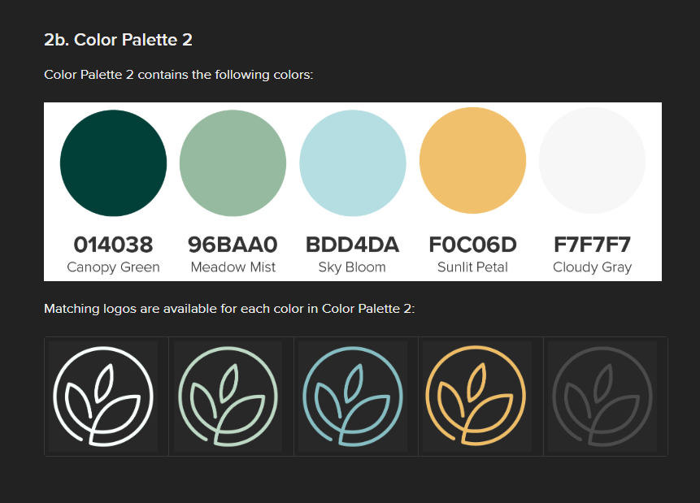

3. Choose a Font Color
The client is considering three different font color options and has asked you to recommend the best one for its website.

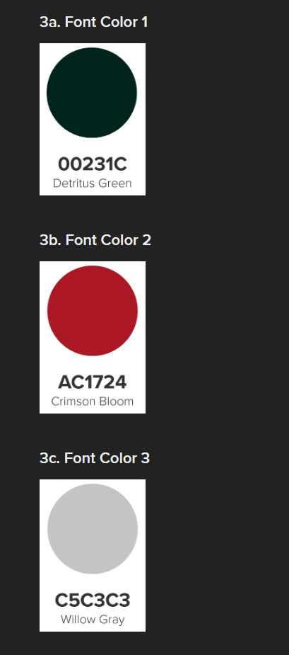
4. Choose the Typography
The client is considering three different typography options and has asked you to recommend the best one for its website.
4a. Typography Option 1
✅ Headings: Georgia Bold
This gives a warm, classic, organic feel that fits plants/gardening well.
✅ Body text + UI: Calibri Normal
Clean, readable, and simple for menus, descriptions, forms, product info.
✅ Buttons / small UI labels (optional): Arial Bold
If you want buttons to look crisp and clear, Arial Bold works great for CTAs.
Recommended sizes (web-friendly)
- H1: Georgia Bold 40px
- H2: Georgia Bold 30px
- H3: Georgia Bold 25px
- Body: Calibri Normal 16–18px
- Small text: Calibri Normal 11–13px
- Buttons: Arial Bold 15–16px

5. Gallery Image Files
The client has provided the following nine images for use on the Gallery page. These images represent the products that the nursery would like to feature on its website. You will organize the images in a 3 X 3 grid pattern on the Gallery page (three rows and three columns). The clarity and dimensions of the images are appropriate for this layout. These images have been licensed from Adobe Stock Photos and may be used without citations in your project.

hint

